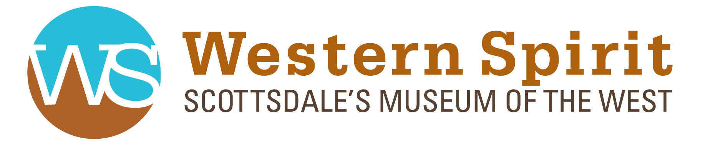

2020 PUBLICITY
Forbes
Explore The Heart of Arizona With Scottsdale's Greatest Virtual Experiences
AEC Bytes
Studio MA: Firm Profile

