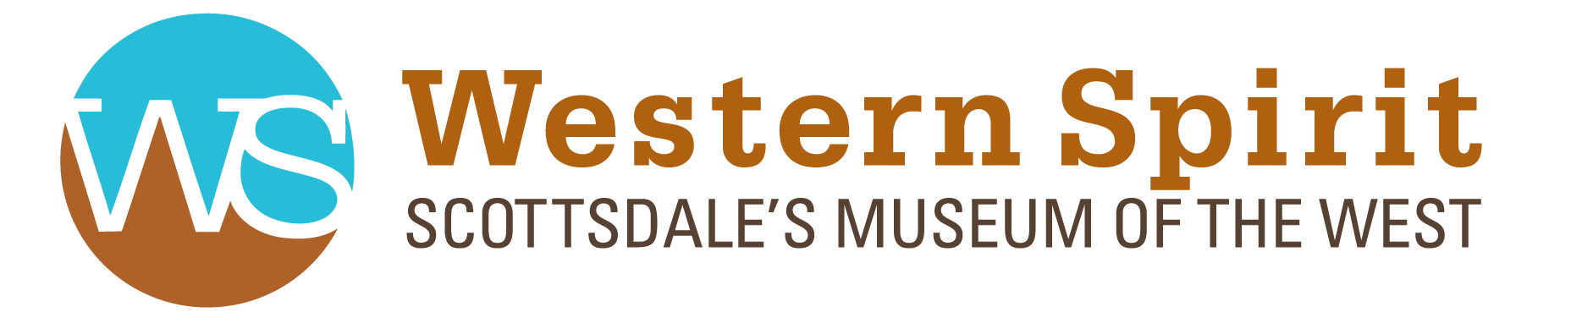

2019 PUBLICITY
‘Saddle Up’ Opening Gala
Frontdoors Media
Western Spirit: Scottsdale's Museum of the West Launches Latest of Nine Exclusive New Exhibitions to Keep Western Storytelling Fresh for Guests
Press Release
Western Spirit: Scottsdale's Museum of the West Among the First to Celebrate the 50th Anniversary of Apollo 11 with New Exhibition Focused on NASA and Western Artist, Paul Calle
Press Release
Exhibition Showcasing Iconic Cowboy Artist and Celebrated Author, Will James, Returns to Scottsdale's Museum of the West
Press Release
Western Spirit: Scottsdale's Museum of the West Launches Exclusive Maynard Dixon Exhibition, World's Most Comprehensive Retrospective Showcasing Dixons Life, Artistic Career
Press Release
Exclusive Tribute Exhibition Showcasing Senator Barry M. Goldwater's Iconic Arizona Photography Opens This Week at Scottsdale's Museum of the West
Press Release
Influence & Inspiration - Charles M. Russell's Women of the West
IMAGES Arizona
Scottsdale's Museum of the West is a One-of-a-Kind Date Spot in the Heart of Old Town
DatingNews.com

