FOR IMMEDIATE RELEASE

Western Spirit: Scottsdale’s Museum of the West Will Honor Native Americans Through the Lens of Early 20th Century Photographer Edward Curtis

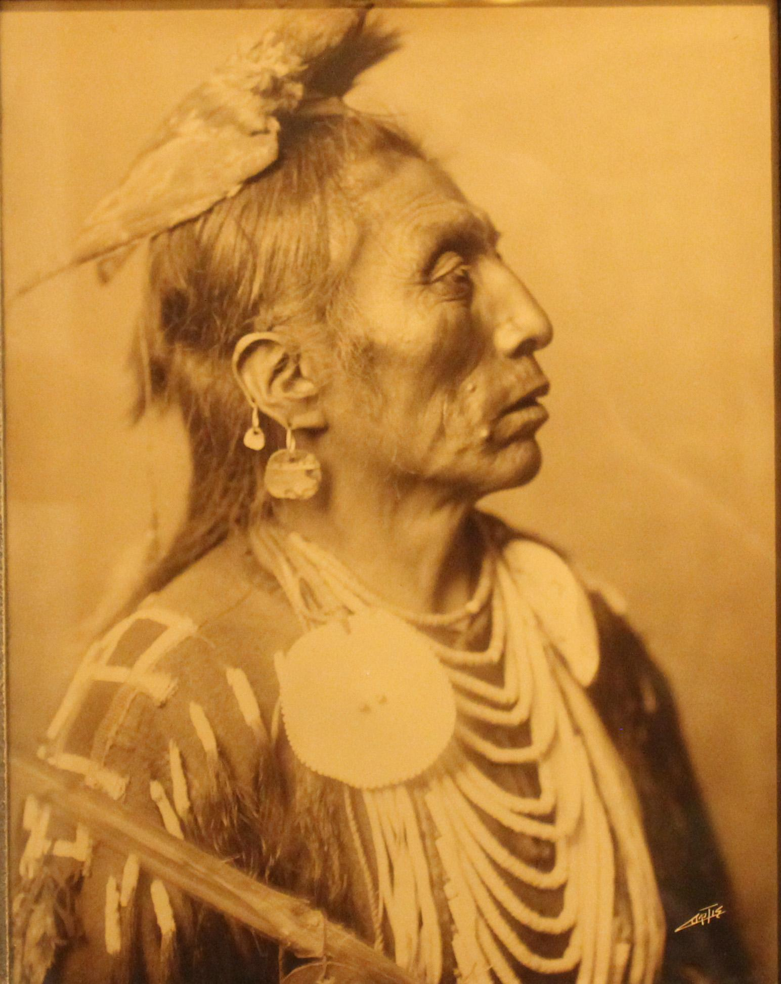
SCOTTSDALE, Ariz. – September 1, 2021 – Western Spirit: Scottsdale’s Museum of the West (SMoW) is proud to announce the remarkable exhibition celebrating the life and works of Edward Curtis, Light and Legacy: The Art and Techniques of Edward S. Curtis, opening on Tuesday, October 19th, 2021.

At the close of the 19th century, many Indigenous Peoples in the United States continued to adhere to traditional ways of life despite the tremendous pressures of modernity. Visionary photographer Edward Curtis saw the importance of honoring these people on film. Over three decades, Curtis created thousands of images, audio recordings, and the earliest motion pictures of Native Peoples, all while making tremendous contributions to the art and science of photography.
Edward S. Curtis,
Medicine Crow. Orotone. The Peterson Family Collection.

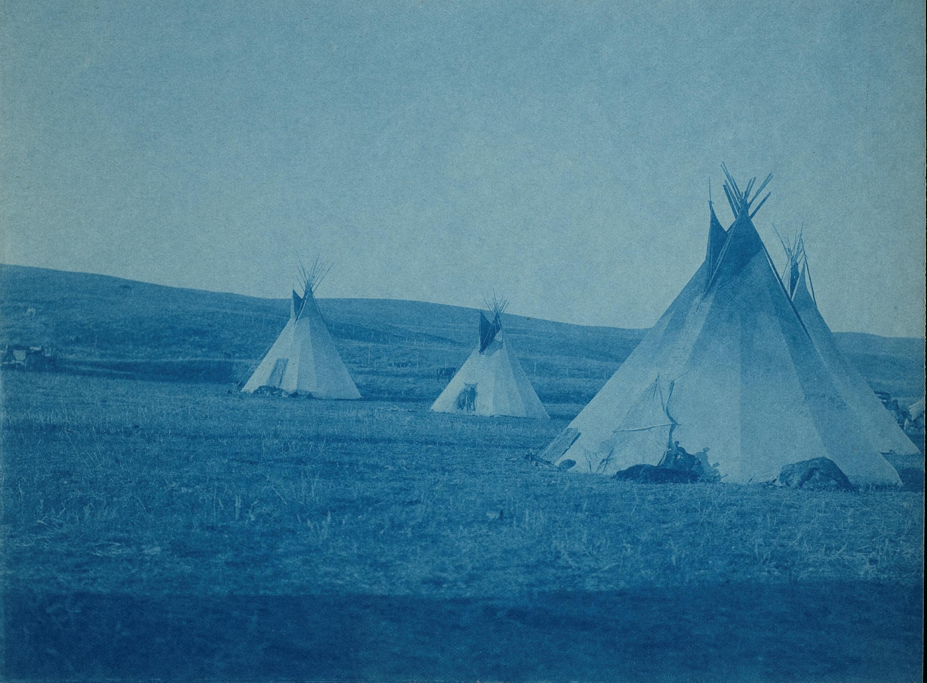
Assistant Director for Collections, Exhibitions and Research, and Co-Curator of the exhibition, Dr. Tricia Loscher, states,
“Based upon years of collecting Curtis’s artwork, Tim Peterson, Scottsdale’s Museum of the West’s Trustee and Western art collector, has used his discerning eye in helping to curate this exhibition. On display will be photogravures; original copper plates; orotones; platinum prints; silver bromides; silver gelatins; cyanotypes; glass plate negatives; and recordings of Native music.” Peterson adds, “The exhibition lays out in two parts. In the first, at least four portraits, one dwelling, and four to six cultural images from each of the first twenty volumes of The North American Indian will be featured. Curtis was a master at using various photographic techniques and materials, and the second half of the exhibition honors his skill. Bottles of the minerals he used to develop his prints, as well as a camera of the kind he traveled with will be on display.”
Edward S. Curtis, Piegan, c. 1910. Cyanotype. 6 x 8 in. The Peterson Family Collection.

Pulitzer Prize recipient, Kiowa author N. Scott Momaday observed: “Taken as a whole, the work of Edward Curtis is a singular achievement. Never before have we seen the Indians of North America so close to the origins of their humanity, their sense of themselves in the world, their innate dignity and self-possession.”

Curtis’s monumental endeavor would all but consume him. His life’s work would almost vanish into history. In the 1970s, in a Boston bookstore warehouse, his art came to light once more. Today, Edward Curtis’s vision lives on beginning on October 19th, 2021 and running through April 30, 2023.

Click HERE for the Curtis exhibition preview video which you can share with your audience.

For more information or to request a press kit, please contact Alison Rose: alison@48westagency.com.

Sponsorship is generously provided by The Peterson Family; Charles F., Jennifer E., and John U. Sands; Theodore “Ted” Stephan; Scottsdale Art Auction; True West Magazine; Ken Amorosano & Bob Boze Bell; and the City of Scottsdale and its Tourism Development Commission.
About Western Spirit: Scottsdale’s Museum of the West (SMoW)
Since its opening in Jan. 2015, SMoW has become a Smithsonian Affiliate organization. The museum is also a recipient of the TripAdvisor Certificate of Excellence, enjoys a 4.5 out of 5-star rating on TripAdvisor and Yelp and is recognized as the “Nation’s Best Western Museum” (2019 & 2021 Editors’ Choice, True West magazine). SMoW features exhibits of Western and Native American art and artifacts, entertaining events and informative programs that bring the West’s heritage, culture and community to life. Exhibitions continuously on display include Canvas of Clay: Hopi Pottery Masterworks from The Allan and Judith Cooke Collection; The A.P. Hays Spirit of the West Collection; Paul Calle’s Life of Exploration: From the Mountains to the Moon; Courage & Crossroads: A Visual Journey through the American West; Dr. Rennard Strickland’s Profound Legacy: The Golden West on the Silver Screen; William P. Healey’s Beaded Gauntlet Collection; Collecting Stories: John Coleman Bronzes from the Collection of Frankie and Howard Alper; and Photographs by Barry M. Goldwater.
Buildings and Campus
SMoW is owned by the City of Scottsdale and the museum is managed by Scottsdale Museum of the West, a non-profit 501(c)(3) organization. It features an award-winning 43,000-square-foot, two-story building designed by Phoenix-based architectural firm Studio Ma. The museum campus was designed by landscape architect Colwell Shelor of Phoenix and features low water-use desert plantings. Both indoor and outdoor spaces are certified as LEED® (Leadership in Energy and Environmental Design) Gold, conserving precious natural resources, while raising public awareness of their vital importance to the Western region.
SMoW also features the beautiful outdoor Christine and Ted Mollring Sculpture Courtyard with a rotating selection of sculptures. The 135-seat Virginia G. Piper Charitable Trust Theater/Auditorium hosts performances, special programs and events. The Sue and Robert Karatz Museum Store offers a rare and wide selection of Western-themed art and gifts.
Museum Hours
Six days weekly, Tuesday through Saturday at its customary hours, 9:30-5 PM, and Sunday, 11-5 PM. Closed Monday. COVID Protocol: Face Coverings are strongly encouraged for all guests and required for non-vaccinated guests. Upon entry, visitors will receive touchless temperature check. Visitors will not be admitted if they have either a temperature or are not feeling well. Hands-free entry at southeast entry way, museum store doors are exit-only. Social distancing signage is in place throughout the museum. Additional measures include plexiglas partitions at transactional areas, hand sanitizer stations at visible locations, recommended personal hygiene procedures in restrooms and restricted elevator capacity guidelines.

Admission Prices
Adults: $20
Seniors (65+) and Active Military: $15
Students (Full-time with ID) and Children (6-17 years): $9
Members and Children 5 and under: FREE
Groups of 15 or more receive a discounted rate.
Thursdays, November-April, Scottsdale residents with proof of residence (e.g., driver’s license, utility bill) receive FREE museum admission.
Location
3830 N. Marshall Way, Scottsdale, AZ 85251
SMoW is located in Old Town Scottsdale, one block west of Scottsdale Road at First Street. The museum is readily accessible from throughout the metro Phoenix area and is within easy walking distance of numerous art galleries, retail stores and restaurants. Day-long, come-and-go admission allows guests to tour SMoW, have a bite to eat in a local Old Town restaurant and return for more viewing.
General Contact:
480-686-9539
www.scottsdalemuseumwest.org

Social Media: Twitter @SMoWest, Instagram @smowest, Facebook @scottsdalemuseumwest.

Media Contact:
Alison Rose
alison@48westagency.com
602-300-3433

